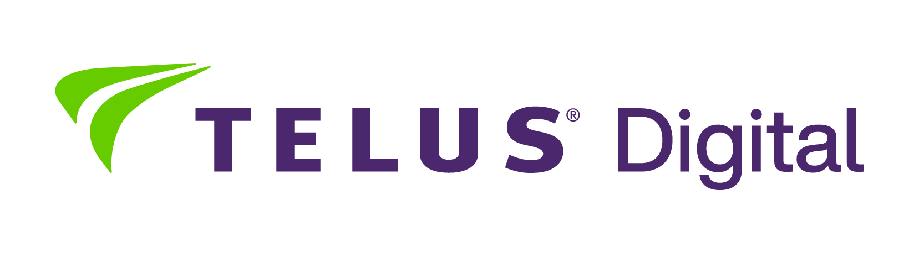

Open positions
August, 2026

Digital Trust and Safety positions:

- Digital Trust and Safety Specialist with Norwegian and English
- Digital Trust and Safety Specialist with Polish and English
- Digital Trust and Safety Specialist with Dutch and English
- Digital Trust and Safety Specialist with French and English
- Digital Trust and Safety Analyst with Arabic and English
- Digital Trust and Safety Analyst with German and English

Gaming positions:
- Player Support Specialist for Games Account with German and English
- Back Office Gaming Support Specialist with French and English

Other:

- Solutions Consultant with Norwegian and English
- Solutions Consultant with Danish and English
- Solutions Consultant with German and English
- Solutions Consultant with Slovak and English
- Solutions Consultant with Czech and English
- Solutions Consultant with Icelandic and English
- Logistics & Delivery Advisor with Dutch and English
- Logistics & Delivery Advisor with French and English
- Russian Speaking Support Specialist

Hybrid or remote positions:

- Client Solutions Consultant with German and English
- Logistics & Delivery Advisor with Dutch and English
- Logistics & Delivery Advisor with French and English

