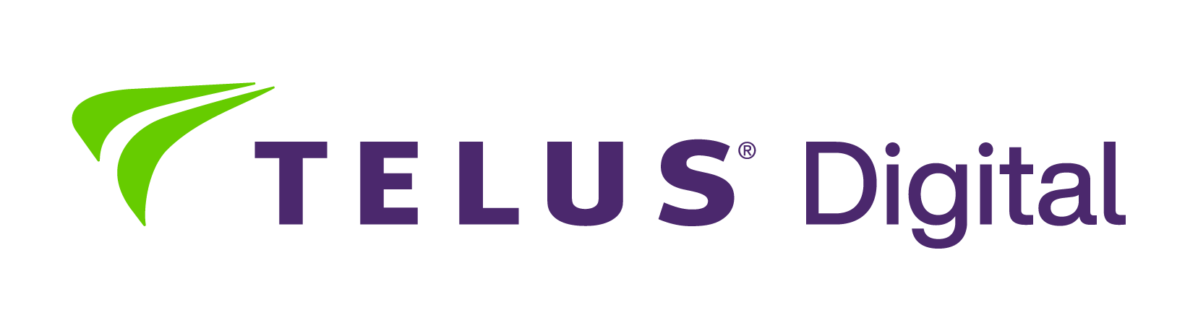

Open positions
April, 2026

Digital Trust and Safety Specialist:

- Digital Trust and Safety Specialist with Polish and English
- Digital Trust and Safety Specialist with Albanian and English
- Digital Trust and Safety Specialist with German and English
- Digital Trust and Safety Specialist with Dutch and English
- Digital Trust and Safety Specialist with French and English
- Digital Trust and Safety Analyst with Danish and English
- Digital Trust and Safety Analyst with German and English
- Digital Trust and Safety Analyst with Dutch and English

Gaming positions:
- Back Office Gaming Support Specialist with German and English
- Back Office Gaming Support Specialist with French and English
- Back Office Gaming Support Specialist with Polish and English
- Player Support Specialist for Supercell Games Account with English

Other:

- Solutions Consultant with Norwegian and English
- Solutions Consultant with Polish and English
- Solutions Consultant with Danish and English
- Solutions Consultant with Czech and English
- Solutions Consultant with Czech and English
- Solutions Consultant with German and English
- Solutions Consultant with Slovenian and English
- Solutions Consultant with Slovak and English
- Solutions Consultant with Latvian and English
- B2B Solutions Consultant with Spanish and English
- Fitbit Products Support Specialist with German and English
- Fitbit Products Support Specialist with Polish and English
- Fitbit Products Support Specialist with Danish and English
- Fitbit Products Support Specialist with Norwegian and English
- Fitbit Products Support Specialist with French and English
- Rent-a-Car Customer Service Consultant (German & English)
- Rent-a-Car Customer Service Consultant (French & English)
- Rent-a-Car Customer Service Consultant (Italian & English)
- Rent-a-Car Customer Service Consultant (Spanish & English)
- Sales Representative with German and English for Energy Audit Deutschland

Remote positions:

- Online Store Advisor with Swedish and English
- iRobot Support Specialist with German and English - Work from Anywhere in Bulgaria
- iRobot Support Specialist with French and English - Work from Anywhere in Bulgaria
iRobot Support Specialist with Dutch and English - Work from Anywhere in Bulgaria
- Travel Support Advisor with German and English
- Travel Support Advisor with Hungarian and English

